Managed File Transfer

In the Websphere MQ One of the plugins is Managed File Transfer.
For this, we can install the MQ Launch application.

Step 1:

Create one Queue Manager named as MFT_QMGR Which we can use it as Coordination , Command and Agent queue managers

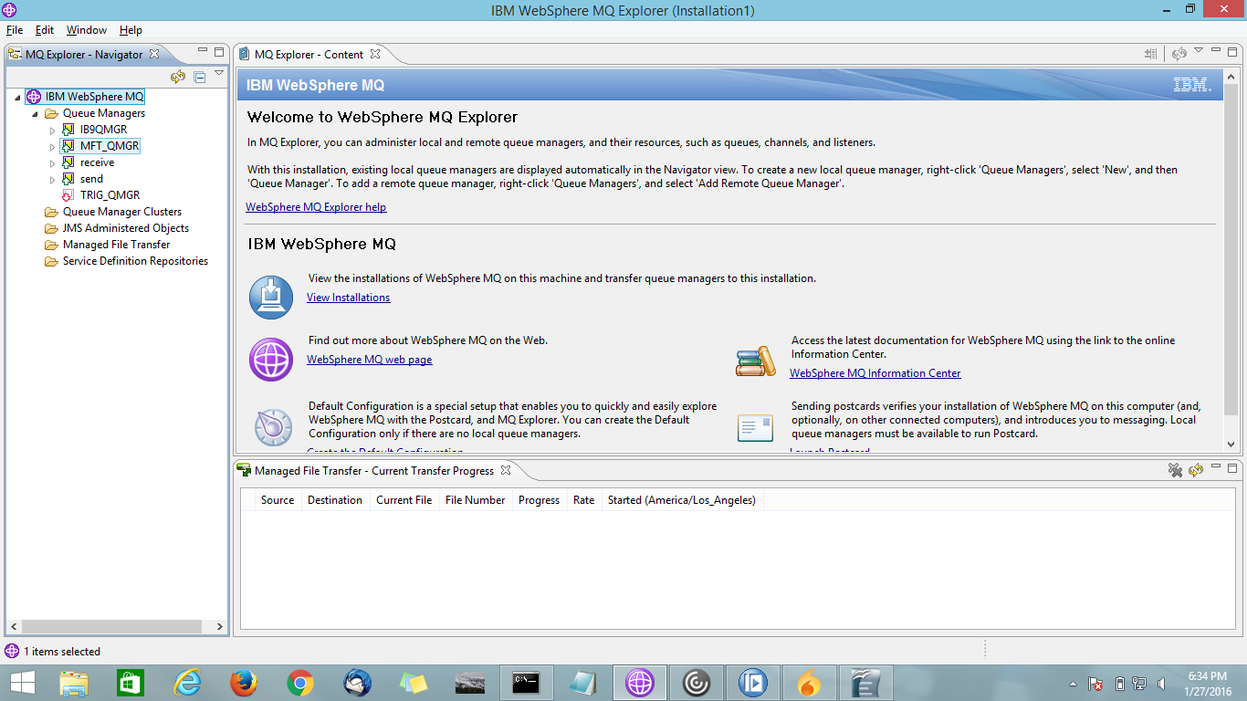
Step 2:
Microsoft Windows [Version 6.3.9600]
(c) 2013 Microsoft Corporation. All rights reserved.

C:\Windows\system32>fteSetupCoordination -coordinationQMgr MFT_QMGR
5724-H72 Copyright IBM Corp. 2008, 2012. ALL RIGHTS RESERVED
BFGCM0242I: Direct the following MQSC definitions for your coordination queue manager 'MFT_QMGR' to an MQSC session if you have not already done so.

DEFINE TOPIC('SYSTEM.FTE') TOPICSTR('SYSTEM.FTE') REPLACE
ALTER TOPIC('SYSTEM.FTE') NPMSGDLV(ALLAVAIL) PMSGDLV(ALLAVAIL)
DEFINE QLOCAL(SYSTEM.FTE) LIKE(SYSTEM.BROKER.DEFAULT.STREAM) REPLACE
ALTER QLOCAL(SYSTEM.FTE) DESCR('Stream for MQMFT Pub/Sub interface')
* Altering namelist: SYSTEM.QPUBSUB.QUEUE.NAMELIST
* Value prior to alteration:
DISPLAY NAMELIST(SYSTEM.QPUBSUB.QUEUE.NAMELIST)
ALTER NAMELIST(SYSTEM.QPUBSUB.QUEUE.NAMELIST) +
NAMES(SYSTEM.BROKER.DEFAULT.STREAM+
,SYSTEM.BROKER.ADMIN.STREAM,SYSTEM.FTE)
* Altering PSMODE. Value prior to alteration:
DISPLAY QMGR PSMODE
ALTER QMGR PSMODE(ENABLED)

BFGCM0243I: A file has been created that contains the MQSC definitions for your coordination queue manager. The file can be found here: 'C:\Program Files (x86)\IBM\WebSphere MQ\mqft\config\MFT_QMGR\MFT_QMGR.mqsc'.

C:\Windows\System32>fteSetupCommands -connectionQMgr MFT_QMGR
5724-H72 Copyright IBM Corp. 2008, 2012. ALL RIGHTS RESERVED
BFGUB0049E: The attempt to create a 'command.properties' property file in directory 'C:\Program Files (x86)\IBM\WebSphere MQ\mqft\config\sample' could not be completed because a property file already exists and the force overwrite parameter (-f) was not specified.

C:\Windows\System32>cd\

C:\>cd C:\Program Files (x86)\IBM\WebSphere MQ\mqft\config\MFT_QMGR

C:\Program Files (x86)\IBM\WebSphere MQ\mqft\config\MFT_QMGR>runmqsc MFT_QMGR < MFT_QMGR.mqsc
5724-H72 (C) Copyright IBM Corp. 1994, 2011. ALL RIGHTS RESERVED.
Starting MQSC for queue manager MFT_QMGR.

1 : DEFINE TOPIC('SYSTEM.FTE') TOPICSTR('SYSTEM.FTE') REPLACE
AMQ8690: WebSphere MQ topic created.
2 : ALTER TOPIC('SYSTEM.FTE') NPMSGDLV(ALLAVAIL) PMSGDLV(ALLAVAIL)
AMQ8691: WebSphere MQ topic changed.
3 : DEFINE QLOCAL(SYSTEM.FTE) LIKE(SYSTEM.BROKER.DEFAULT.STREAM) REPLACE
AMQ8006: WebSphere MQ queue created.
4 : ALTER QLOCAL(SYSTEM.FTE) DESCR('Stream for MQMFT Pub/Sub interface')
AMQ8008: WebSphere MQ queue changed.
: * Altering namelist: SYSTEM.QPUBSUB.QUEUE.NAMELIST
: * Value prior to alteration:
5 : DISPLAY NAMELIST(SYSTEM.QPUBSUB.QUEUE.NAMELIST)
AMQ8550: Display namelist details.
NAMELIST(SYSTEM.QPUBSUB.QUEUE.NAMELIST)
NAMCOUNT(2)
NAMES(SYSTEM.BROKER.DEFAULT.STREAM
,SYSTEM.BROKER.ADMIN.STREAM)
DESCR(A list of queues for the queued Pub/Sub interface to monitor)
ALTDATE(2016-01-27) ALTTIME(18.21.24)
6 : ALTER NAMELIST(SYSTEM.QPUBSUB.QUEUE.NAMELIST) +
: NAMES(SYSTEM.BROKER.DEFAULT.STREAM+
: ,SYSTEM.BROKER.ADMIN.STREAM,SYSTEM.FTE)
AMQ8551: WebSphere MQ namelist changed.
: * Altering PSMODE. Value prior to alteration:
7 : DISPLAY QMGR PSMODE
AMQ8408: Display Queue Manager details.
QMNAME(MFT_QMGR) PSMODE(ENABLED)
8 : ALTER QMGR PSMODE(ENABLED)
AMQ8005: WebSphere MQ queue manager changed.
8 MQSC commands read.
No commands have a syntax error.
All valid MQSC commands were processed.

After the above command, close the MQ Explorer and Open it (automatically set the global configuration)
C:\Program Files (x86)\IBM\WebSphere MQ\mqft\config\MFT_QMGR>cd\

C:\>fteCreateAgent -agentName SRC -agentQMgr MFT_QMGR
5724-H72 Copyright IBM Corp. 2008, 2012. ALL RIGHTS RESERVED
BFGCM0238I: Direct the following MQSC definitions for agent 'SRC' to queue manager 'MFT_QMGR'.

DEFINE QLOCAL(SYSTEM.FTE.COMMAND.SRC) +
DEFPRTY(0) +
DEFSOPT(SHARED) +
GET(ENABLED) +
MAXDEPTH(5000) +
MAXMSGL(4194304) +
MSGDLVSQ(PRIORITY) +
PUT(ENABLED) +
RETINTVL(999999999) +
SHARE +
NOTRIGGER +
USAGE(NORMAL) +
REPLACE
DEFINE QLOCAL(SYSTEM.FTE.DATA.SRC) +
DEFPRTY(0) +
DEFSOPT(SHARED) +
GET(ENABLED) +
MAXDEPTH(5000) +
MAXMSGL(4194304) +
MSGDLVSQ(PRIORITY) +
PUT(ENABLED) +
RETINTVL(999999999) +
SHARE +
NOTRIGGER +
USAGE(NORMAL) +
REPLACE
DEFINE QLOCAL(SYSTEM.FTE.REPLY.SRC) +
DEFPRTY(0) +
DEFSOPT(SHARED) +
GET(ENABLED) +
MAXDEPTH(5000) +
MAXMSGL(4194304) +
MSGDLVSQ(PRIORITY) +
PUT(ENABLED) +
RETINTVL(999999999) +
SHARE +
NOTRIGGER +
USAGE(NORMAL) +
REPLACE
DEFINE QLOCAL(SYSTEM.FTE.STATE.SRC) +
DEFPRTY(0) +
DEFSOPT(SHARED) +
GET(ENABLED) +
MAXDEPTH(5000) +
MAXMSGL(4194304) +
MSGDLVSQ(PRIORITY) +
PUT(ENABLED) +
RETINTVL(999999999) +
SHARE +
NOTRIGGER +
USAGE(NORMAL) +
REPLACE
DEFINE QLOCAL(SYSTEM.FTE.EVENT.SRC) +
DEFPRTY(0) +
DEFSOPT(SHARED) +
GET(ENABLED) +
MAXDEPTH(5000) +
MAXMSGL(4194304) +
MSGDLVSQ(PRIORITY) +
PUT(ENABLED) +
RETINTVL(999999999) +
SHARE +
NOTRIGGER +
USAGE(NORMAL) +
REPLACE
DEFINE QLOCAL(SYSTEM.FTE.AUTHAGT1.SRC) +
DEFPRTY(0) +
DEFSOPT(SHARED) +
GET(ENABLED) +
MAXDEPTH(0) +
MAXMSGL(0) +
MSGDLVSQ(PRIORITY) +
PUT(ENABLED) +
RETINTVL(999999999) +
SHARE +
NOTRIGGER +
USAGE(NORMAL) +
REPLACE
DEFINE QLOCAL(SYSTEM.FTE.AUTHTRN1.SRC) +
DEFPRTY(0) +
DEFSOPT(SHARED) +
GET(ENABLED) +
MAXDEPTH(0) +
MAXMSGL(0) +
MSGDLVSQ(PRIORITY) +
PUT(ENABLED) +
RETINTVL(999999999) +
SHARE +
NOTRIGGER +
USAGE(NORMAL) +
REPLACE
DEFINE QLOCAL(SYSTEM.FTE.AUTHOPS1.SRC) +
DEFPRTY(0) +
DEFSOPT(SHARED) +
GET(ENABLED) +
MAXDEPTH(0) +
MAXMSGL(0) +
MSGDLVSQ(PRIORITY) +
PUT(ENABLED) +
RETINTVL(999999999) +
SHARE +
NOTRIGGER +
USAGE(NORMAL) +
REPLACE
DEFINE QLOCAL(SYSTEM.FTE.AUTHSCH1.SRC) +
DEFPRTY(0) +
DEFSOPT(SHARED) +
GET(ENABLED) +
MAXDEPTH(0) +
MAXMSGL(0) +
MSGDLVSQ(PRIORITY) +
PUT(ENABLED) +
RETINTVL(999999999) +
SHARE +
NOTRIGGER +
USAGE(NORMAL) +
REPLACE
DEFINE QLOCAL(SYSTEM.FTE.AUTHMON1.SRC) +
DEFPRTY(0) +
DEFSOPT(SHARED) +
GET(ENABLED) +
MAXDEPTH(0) +
MAXMSGL(0) +
MSGDLVSQ(PRIORITY) +
PUT(ENABLED) +
RETINTVL(999999999) +
SHARE +
NOTRIGGER +
USAGE(NORMAL) +
REPLACE
DEFINE QLOCAL(SYSTEM.FTE.AUTHADM1.SRC) +
DEFPRTY(0) +
DEFSOPT(SHARED) +
GET(ENABLED) +
MAXDEPTH(0) +
MAXMSGL(0) +
MSGDLVSQ(PRIORITY) +
PUT(ENABLED) +
RETINTVL(999999999) +
SHARE +
NOTRIGGER +
USAGE(NORMAL) +
REPLACE

BFGCM0239I: A file has been created containing the MQSC definitions to create your agent. The file can be found here: 'C:\Program Files (x86)\IBM\WebSphere MQ\mqft\config\sample\agents\SRC\SRC_create.mqsc'.
BFGCM0241I: A file has been created containing the MQSC definitions to delete your agent. The file can be found here: 'C:\Program Files (x86)\IBM\WebSphere MQ\mqft\config\sample\agents\SRC\SRC_delete.mqsc'.
BFGMQ1007W: The coordination queue manager cannot be contacted or has refused a connection attempt. The WebSphere MQ reason code was 2087. The agent's presence will not be published.
BFGCL0254I: Agent configured successfully. The agent has not been registered with the coordination queue manager.

C:\>
MAXMSGL(4194304) +
MSGDLVSQ(PRIORITY) +
PUT(ENABLED) +
RETINTVL(999999999) +
SHARE +
NOTRIGGER +
USAGE(NORMAL) +
REPLACE
DEFINE QLOCAL(SYSTEM.FTE.DATA.SRC) +
DEFPRTY(0) +
DEFSOPT(SHARED) +
GET(ENABLED) +
MAXDEPTH(5000) +
MAXMSGL(4194304) +
MSGDLVSQ(PRIORITY) +
PUT(ENABLED) +
RETINTVL(999999999) +
SHARE +
NOTRIGGER +
USAGE(NORMAL) +
REPLACE
DEFINE QLOCAL(SYSTEM.FTE.REPLY.SRC) +
DEFPRTY(0) +
DEFSOPT(SHARED) +
GET(ENABLED) +
MAXDEPTH(5000) +
MAXMSGL(4194304) +
MSGDLVSQ(PRIORITY) +
PUT(ENABLED) +
RETINTVL(999999999) +
SHARE +
NOTRIGGER +
USAGE(NORMAL) +
REPLACE
DEFINE QLOCAL(SYSTEM.FTE.STATE.SRC) +
DEFPRTY(0) +
DEFSOPT(SHARED) +
GET(ENABLED) +
MAXDEPTH(5000) +
MAXMSGL(4194304) +
MSGDLVSQ(PRIORITY) +
PUT(ENABLED) +
RETINTVL(999999999) +
SHARE +
NOTRIGGER +
USAGE(NORMAL) +
REPLACE
DEFINE QLOCAL(SYSTEM.FTE.EVENT.SRC) +
DEFPRTY(0) +
DEFSOPT(SHARED) +
GET(ENABLED) +
MAXDEPTH(5000) +
MAXMSGL(4194304) +
MSGDLVSQ(PRIORITY) +
PUT(ENABLED) +
RETINTVL(999999999) +
SHARE +
NOTRIGGER +
USAGE(NORMAL) +
REPLACE
DEFINE QLOCAL(SYSTEM.FTE.AUTHAGT1.SRC) +
DEFPRTY(0) +
DEFSOPT(SHARED) +
GET(ENABLED) +
MAXDEPTH(0) +
MAXMSGL(0) +
MSGDLVSQ(PRIORITY) +
PUT(ENABLED) +
RETINTVL(999999999) +
SHARE +
NOTRIGGER +
USAGE(NORMAL) +
REPLACE
DEFINE QLOCAL(SYSTEM.FTE.AUTHTRN1.SRC) +
DEFPRTY(0) +
DEFSOPT(SHARED) +
GET(ENABLED) +
MAXDEPTH(0) +
MAXMSGL(0) +
MSGDLVSQ(PRIORITY) +
PUT(ENABLED) +
RETINTVL(999999999) +
SHARE +
NOTRIGGER +
USAGE(NORMAL) +
REPLACE
DEFINE QLOCAL(SYSTEM.FTE.AUTHOPS1.SRC) +
DEFPRTY(0) +
DEFSOPT(SHARED) +
GET(ENABLED) +
MAXDEPTH(0) +
MAXMSGL(0) +
MSGDLVSQ(PRIORITY) +
PUT(ENABLED) +
RETINTVL(999999999) +
SHARE +
NOTRIGGER +
USAGE(NORMAL) +
REPLACE
DEFINE QLOCAL(SYSTEM.FTE.AUTHSCH1.SRC) +
DEFPRTY(0) +
DEFSOPT(SHARED) +
GET(ENABLED) +
MAXDEPTH(0) +
MAXMSGL(0) +
MSGDLVSQ(PRIORITY) +
PUT(ENABLED) +
RETINTVL(999999999) +
SHARE +
NOTRIGGER +
USAGE(NORMAL) +
REPLACE
DEFINE QLOCAL(SYSTEM.FTE.AUTHMON1.SRC) +
DEFPRTY(0) +
DEFSOPT(SHARED) +
GET(ENABLED) +
MAXDEPTH(0) +
MAXMSGL(0) +
MSGDLVSQ(PRIORITY) +
PUT(ENABLED) +
RETINTVL(999999999) +
SHARE +
NOTRIGGER +
USAGE(NORMAL) +
REPLACE
DEFINE QLOCAL(SYSTEM.FTE.AUTHADM1.SRC) +
DEFPRTY(0) +
DEFSOPT(SHARED) +
GET(ENABLED) +
MAXDEPTH(0) +
MAXMSGL(0) +
MSGDLVSQ(PRIORITY) +
PUT(ENABLED) +
RETINTVL(999999999) +
SHARE +
NOTRIGGER +
USAGE(NORMAL) +
REPLACE

BFGCM0239I: A file has been created containing the MQSC definitions to create your agent. The file can be found here: 'C:\Program Files (x86)\IBM\WebSphere MQ\mqft\config\MFT_QMGR\agents\SRC\SRC_create.mqsc'.
BFGCM0241I: A file has been created containing the MQSC definitions to delete your agent. The file can be found here: 'C:\Program Files (x86)\IBM\WebSphere MQ\mqft\config\MFT_QMGR\agents\SRC\SRC_delete.mqsc'.
BFGMQ1007W: The coordination queue manager cannot be contacted or has refused a connection attempt. The WebSphere MQ reason code was 2059. The agent's presence will not be published.
BFGCL0254I: Agent configured successfully. The agent has not been registered with the coordination queue manager.

C:\Windows\System32>fteCreateAgent -agentName DEST -agentQMgr MFT_QMGR
5724-H72 Copyright IBM Corp. 2008, 2012. ALL RIGHTS RESERVED
BFGCM0238I: Direct the following MQSC definitions for agent 'DEST' to queue manager 'MFT_QMGR'.

DEFINE QLOCAL(SYSTEM.FTE.COMMAND.DEST) +
DEFPRTY(0) +
DEFSOPT(SHARED) +
GET(ENABLED) +
MAXDEPTH(5000) +
MAXMSGL(4194304) +
MSGDLVSQ(PRIORITY) +
PUT(ENABLED) +
RETINTVL(999999999) +
SHARE +
NOTRIGGER +
USAGE(NORMAL) +
REPLACE
DEFINE QLOCAL(SYSTEM.FTE.DATA.DEST) +
DEFPRTY(0) +
DEFSOPT(SHARED) +
GET(ENABLED) +
MAXDEPTH(5000) +
MAXMSGL(4194304) +
MSGDLVSQ(PRIORITY) +
PUT(ENABLED) +
RETINTVL(999999999) +
SHARE +
NOTRIGGER +
USAGE(NORMAL) +
REPLACE
DEFINE QLOCAL(SYSTEM.FTE.REPLY.DEST) +
DEFPRTY(0) +
DEFSOPT(SHARED) +
GET(ENABLED) +
MAXDEPTH(5000) +
MAXMSGL(4194304) +
MSGDLVSQ(PRIORITY) +
PUT(ENABLED) +
RETINTVL(999999999) +
SHARE +
NOTRIGGER +
USAGE(NORMAL) +
REPLACE
DEFINE QLOCAL(SYSTEM.FTE.STATE.DEST) +
DEFPRTY(0) +
DEFSOPT(SHARED) +
GET(ENABLED) +
MAXDEPTH(5000) +
MAXMSGL(4194304) +
MSGDLVSQ(PRIORITY) +
PUT(ENABLED) +
RETINTVL(999999999) +
SHARE +
NOTRIGGER +
USAGE(NORMAL) +
REPLACE
DEFINE QLOCAL(SYSTEM.FTE.EVENT.DEST) +
DEFPRTY(0) +
DEFSOPT(SHARED) +
GET(ENABLED) +
MAXDEPTH(5000) +
MAXMSGL(4194304) +
MSGDLVSQ(PRIORITY) +
PUT(ENABLED) +
RETINTVL(999999999) +
SHARE +
NOTRIGGER +
USAGE(NORMAL) +
REPLACE
DEFINE QLOCAL(SYSTEM.FTE.AUTHAGT1.DEST) +
DEFPRTY(0) +
DEFSOPT(SHARED) +
GET(ENABLED) +
MAXDEPTH(0) +
MAXMSGL(0) +
MSGDLVSQ(PRIORITY) +
PUT(ENABLED) +
RETINTVL(999999999) +
SHARE +
NOTRIGGER +
USAGE(NORMAL) +
REPLACE
DEFINE QLOCAL(SYSTEM.FTE.AUTHTRN1.DEST) +
DEFPRTY(0) +
DEFSOPT(SHARED) +
GET(ENABLED) +
MAXDEPTH(0) +
MAXMSGL(0) +
MSGDLVSQ(PRIORITY) +
PUT(ENABLED) +
RETINTVL(999999999) +
SHARE +
NOTRIGGER +
USAGE(NORMAL) +
REPLACE
DEFINE QLOCAL(SYSTEM.FTE.AUTHOPS1.DEST) +
DEFPRTY(0) +
DEFSOPT(SHARED) +
GET(ENABLED) +
MAXDEPTH(0) +
MAXMSGL(0) +
MSGDLVSQ(PRIORITY) +
PUT(ENABLED) +
RETINTVL(999999999) +
SHARE +
NOTRIGGER +
USAGE(NORMAL) +
REPLACE
DEFINE QLOCAL(SYSTEM.FTE.AUTHSCH1.DEST) +
DEFPRTY(0) +
DEFSOPT(SHARED) +
GET(ENABLED) +
MAXDEPTH(0) +
MAXMSGL(0) +
MSGDLVSQ(PRIORITY) +
PUT(ENABLED) +
RETINTVL(999999999) +
SHARE +
NOTRIGGER +
USAGE(NORMAL) +
REPLACE
DEFINE QLOCAL(SYSTEM.FTE.AUTHMON1.DEST) +
DEFPRTY(0) +
DEFSOPT(SHARED) +
GET(ENABLED) +
MAXDEPTH(0) +
MAXMSGL(0) +
MSGDLVSQ(PRIORITY) +
PUT(ENABLED) +
RETINTVL(999999999) +
SHARE +
NOTRIGGER +
USAGE(NORMAL) +
REPLACE
DEFINE QLOCAL(SYSTEM.FTE.AUTHADM1.DEST) +
DEFPRTY(0) +
DEFSOPT(SHARED) +
GET(ENABLED) +
MAXDEPTH(0) +
MAXMSGL(0) +
MSGDLVSQ(PRIORITY) +
PUT(ENABLED) +
RETINTVL(999999999) +
SHARE +
NOTRIGGER +
USAGE(NORMAL) +
REPLACE

BFGCM0239I: A file has been created containing the MQSC definitions to create your agent. The file can be found here: 'C:\Program Files (x86)\IBM\WebSphere MQ\mqft\config\MFT_QMGR\agents\DEST\DEST_create.mqsc'.
BFGCM0241I: A file has been created containing the MQSC definitions to delete your agent. The file can be found here: 'C:\Program Files (x86)\IBM\WebSphere MQ\mqft\config\MFT_QMGR\agents\DEST\DEST_delete.mqsc'.
BFGMQ1007W: The coordination queue manager cannot be contacted or has refused a connection attempt. The WebSphere MQ reason code was 2059. The agent's presence will not be published.
BFGCL0254I: Agent configured successfully. The agent has not been registered with the coordination queue manager.

C:\Program Files (x86)\IBM\WebSphere MQ\mqft\config\MFT_QMGR\agents\SRC>runmqsc SRC < SRC_create.mqsc
5724-H72 (C) Copyright IBM Corp. 1994, 2011. ALL RIGHTS RESERVED.
Starting MQSC for queue manager SRC.

AMQ8118: WebSphere MQ queue manager does not exist.

No MQSC commands read.
No commands have a syntax error.
All valid MQSC commands were processed.

C:\Program Files (x86)\IBM\WebSphere MQ\mqft\config\MFT_QMGR\agents\SRC>cd..

C:\Program Files (x86)\IBM\WebSphere MQ\mqft\config\MFT_QMGR\agents>cd DEST

C:\Program Files (x86)\IBM\WebSphere MQ\mqft\config\MFT_QMGR\agents\DEST>runmqsc DEST < DEST_create.mqsc
5724-H72 (C) Copyright IBM Corp. 1994, 2011. ALL RIGHTS RESERVED.
Starting MQSC for queue manager DEST.

AMQ8118: WebSphere MQ queue manager does not exist.

No MQSC commands read.
No commands have a syntax error.
All valid MQSC commands were processed.

C:\Program Files (x86)\IBM\WebSphere MQ\mqft\config\MFT_QMGR\agents\DEST>cd\

C:\>cd Windows\System32

C:\Windows\System32>ftestartagent src
5724-H72 Copyright IBM Corp. 2008, 2012. ALL RIGHTS RESERVED
BFGCL0030I: The request to start agent 'SRC' on this machine has been submitted.
BFGCL0031I: Agent log files located at: C:\Program Files (x86)\IBM\WebSphere MQ\mqft\logs\MFT_QMGR\agents\SRC\logs

C:\Windows\System32>fteListAgents
5724-H72 Copyright IBM Corp. 2008, 2012. ALL RIGHTS RESERVED
Agent Name: Queue Manager Name: Status:
DEST MFT_QMGR STOPPED
SRC MFT_QMGR READY

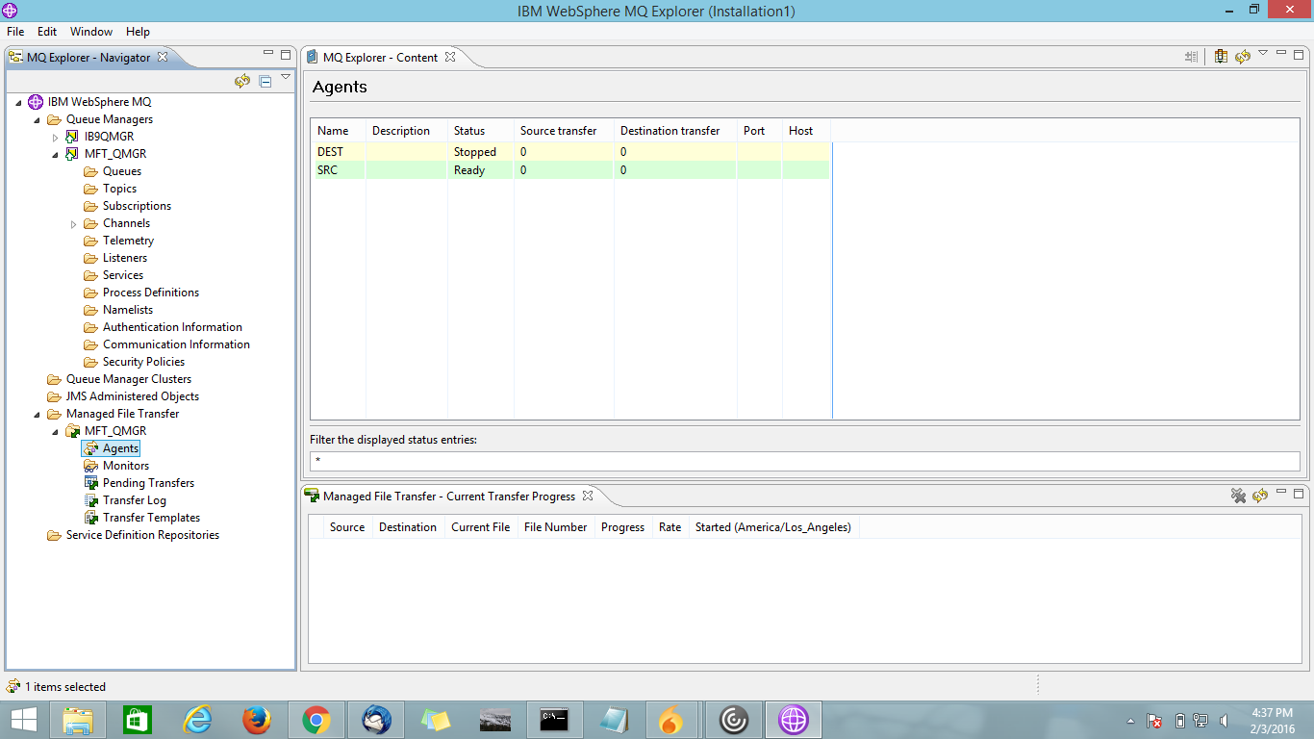

C:\Windows\System32>ftestartagent dest
5724-H72 Copyright IBM Corp. 2008, 2012. ALL RIGHTS RESERVED
BFGCL0030I: The request to start agent 'DEST' on this machine has been submitted.
BFGCL0031I: Agent log files located at: C:\Program Files (x86)\IBM\WebSphere MQ\mqft\logs\MFT_QMGR\agents\DEST\logs

C:\Windows\System32>fteListAgents
5724-H72 Copyright IBM Corp. 2008, 2012. ALL RIGHTS RESERVED
Agent Name: Queue Manager Name: Status:
DEST MFT_QMGR READY
SRC MFT_QMGR READY

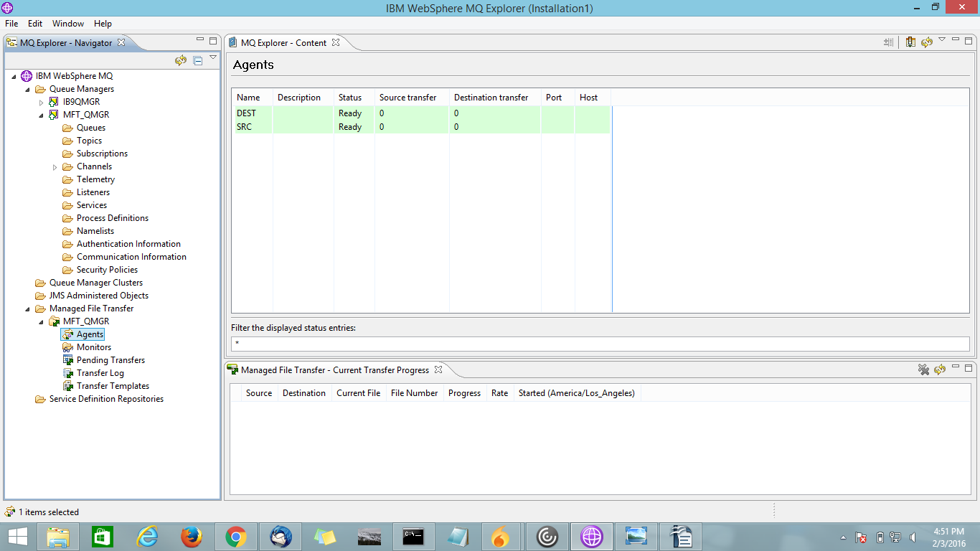

Common problems on Agent

What to do if the fteListAgents command shows an agent status of UNREACHABLE

Your agent is running and responds successfully to the ftePingAgent command, and files are being transferred normally, but the agent is listed as UNREACHABLE by the fteListAgents command.

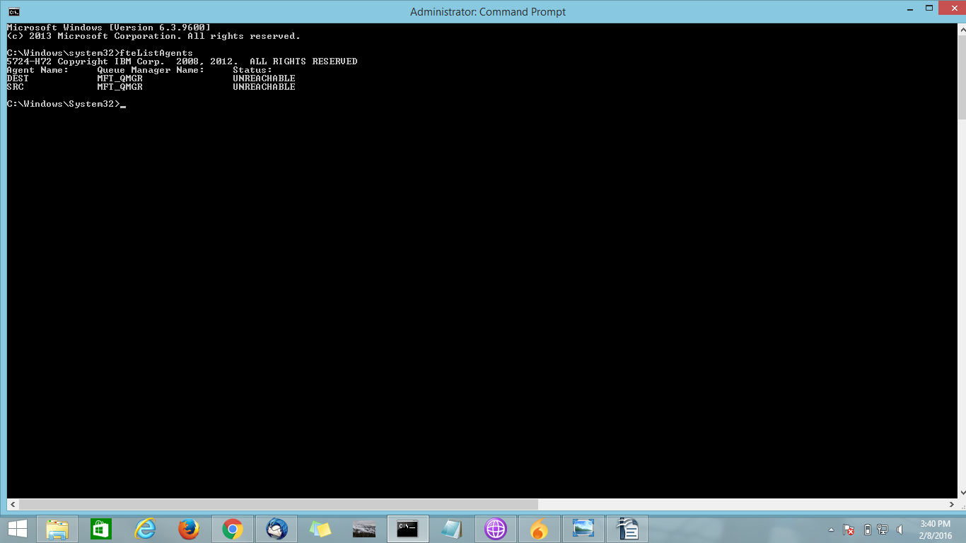

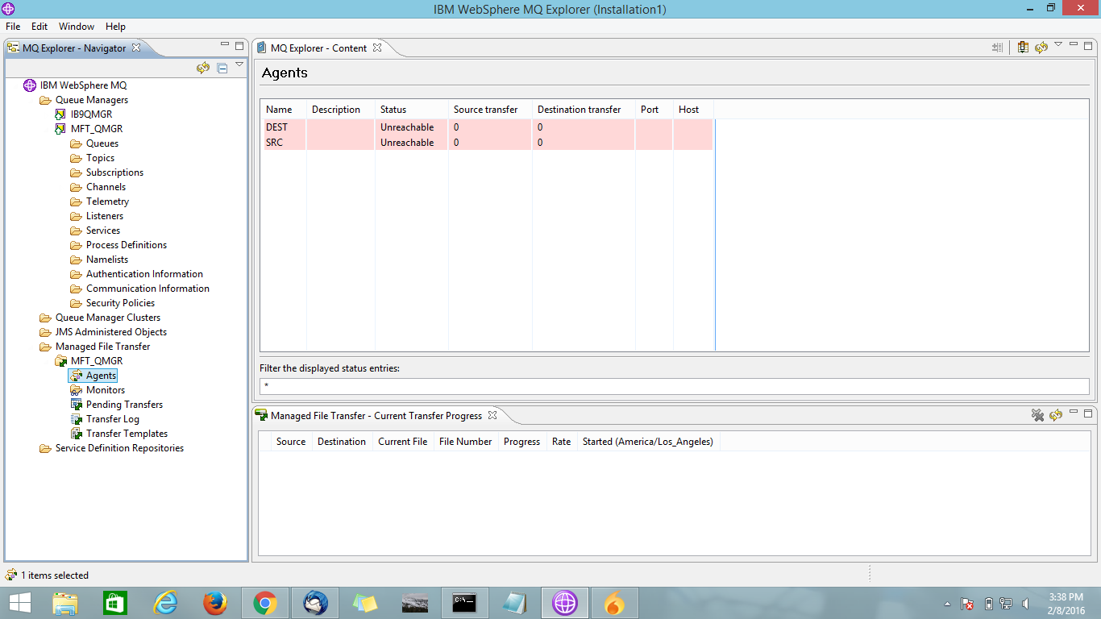

Why this problem occurs means normally, the agent publishes its status to the coordination queue manager.
The frequency that the agent publishes its status is controlled by the following two agent properties:
agentStatusPublishRateLimit
The maximum rate in seconds that the agent republishes its status because of a change in file transfer status.

agentStatusPublishRateMin
The minimum rate in seconds that the agent publishes its status. This value must be greater than or equal to the value of the agentStatusPublishRateLimit property.

- Using the default settings, clocks that are out-of-sync between the agent system and the coordination queue manager system cause this issue, if the difference between the times is greater than 303 seconds.
- Agent status messages are considered stale if the message was sent more than the value of agentStatusPublishRateMin + the value of agentStatusJitterTolerance seconds ago.
- An agent with a stale status message is reported as UNREACHABLE by the fteListAgents command.

By default, the value of the agentStatusJitterTolerance property is 3000 milliseconds and the value of the agentStatusPublishRateMin property is 300 seconds. If the time difference between the machines plus the effective publish rate is greater than the sum of agentStatusPublishRateMin + agentStatusJitterTolerance, the time difference causes the UNREACHABLE agent status.

How to resolve this problem?

- Correct the time setting differences between the agent host machine and the machine hosting the coordination queue manager, so that they are in sync.

- Increase the value of the agentStatusJitterTolerance property to account for the time difference. When you run the fteListAgents command, the value of agentStatusJitterTolerance is determined by the coordination.properties configuration file in the MQMFT config directory.
- Therefore, set the property in the coordination.properties file of the MQMFT installation that the fteListAgents command is being run on.

Fileinput nodes deal with "standard" file transfer based on arrival of files into the local file system, or the use of FTP / SFTP to access them.
FTEInput nodes relate to the IBM MQ FTE product, which transfers files over MQ to avoid the limitations of "standard" file transfer.

